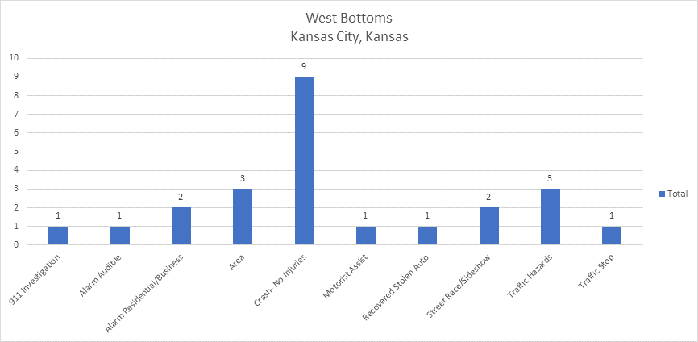

Row Labels | Count of Call Narrative
911 Investigation | 1
Alarm Audible | 1
Alarm Residential/Business | 2
Area | 3
Crash- No Injuries | 9
Motorist Assist | 1
Recovered Stolen Auto | 1
Street Race/Sideshow | 2
Traffic Hazards | 3
Traffic Stop | 1
Grand Total | 24

Here are the stats for the Kansas Side of the West Bottoms for the month of April 2026.

